ASSIGNMENT NO 11

1) write a query that uses a subquery to obtain all orders for the customer named Cisnerous.Assume you do not know hos customer number(cnum)
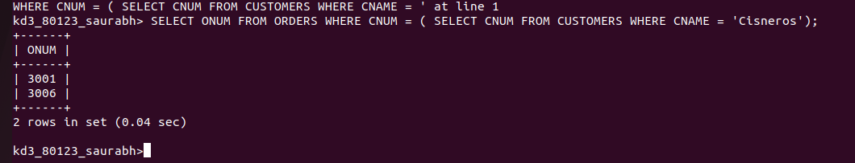

2) write a query that produces the names and ratings of all customers who have above – average orders.
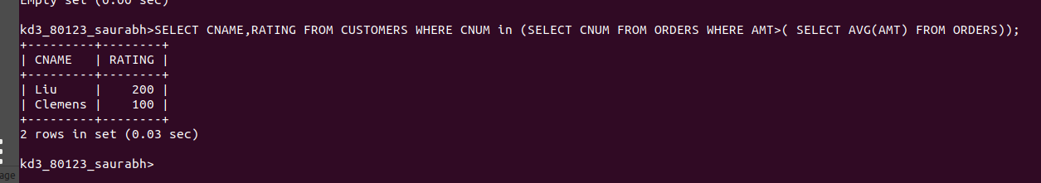

3) write a query that selects the total amount in oders for each salesperson for whom thsis total is greater that the amount of the largest oder in the table.
